**FACE vegetation survey in 2013 and 2014**

* Analysis on biodiversity indices
  + Diversity (H’): Shannon-Weaver
    - 🡪 decreased at eCO2
  + Species richness (S): number of Spp.
  + Evenness (J): Pielou's evenness
    - 🡪 decreased at eCO2
* Analysis on plant functional group (PFG) ratios and native or introduced spp ratio
  + C4:C3
    - 🡪 increased at ambient
  + Legueme:Non legume
  + Introduced:Native
    - 🡪 Decreased more at eCO2

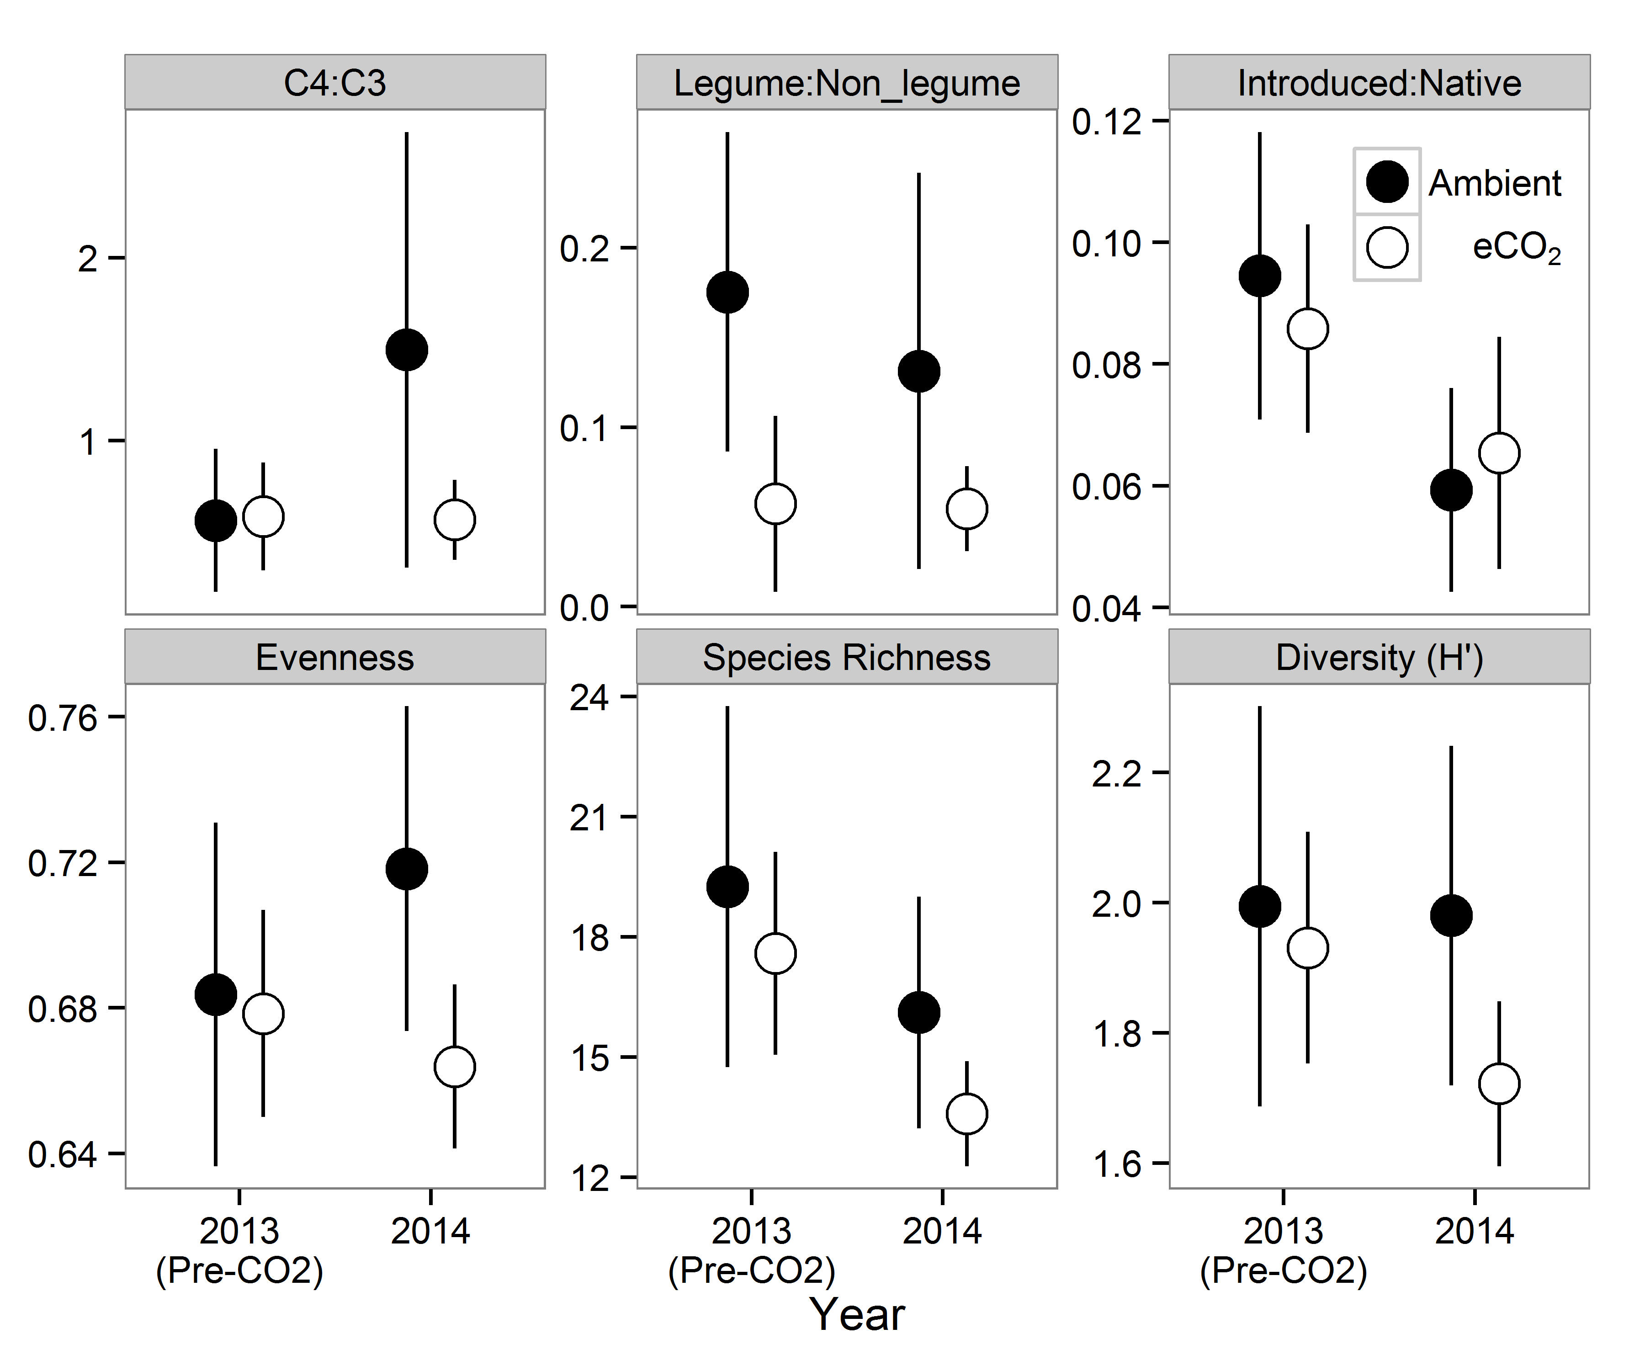

* Dissimilarity in community composition between 2013 and 2014 for each plot
  + All species
    - 🡪 not difference between CO2 treatments when compared all species
    - There was negative correlation with soil moisture
  + Plant functional groups (PFG)
    - 🡪 dissimilarity in PFG composition was smaller at eCO2

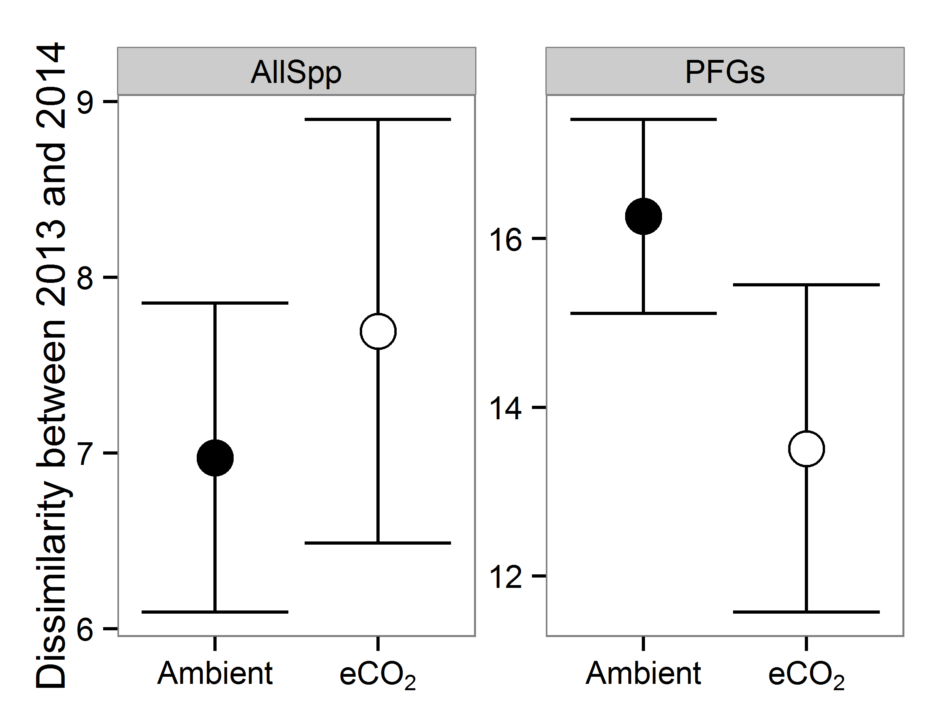

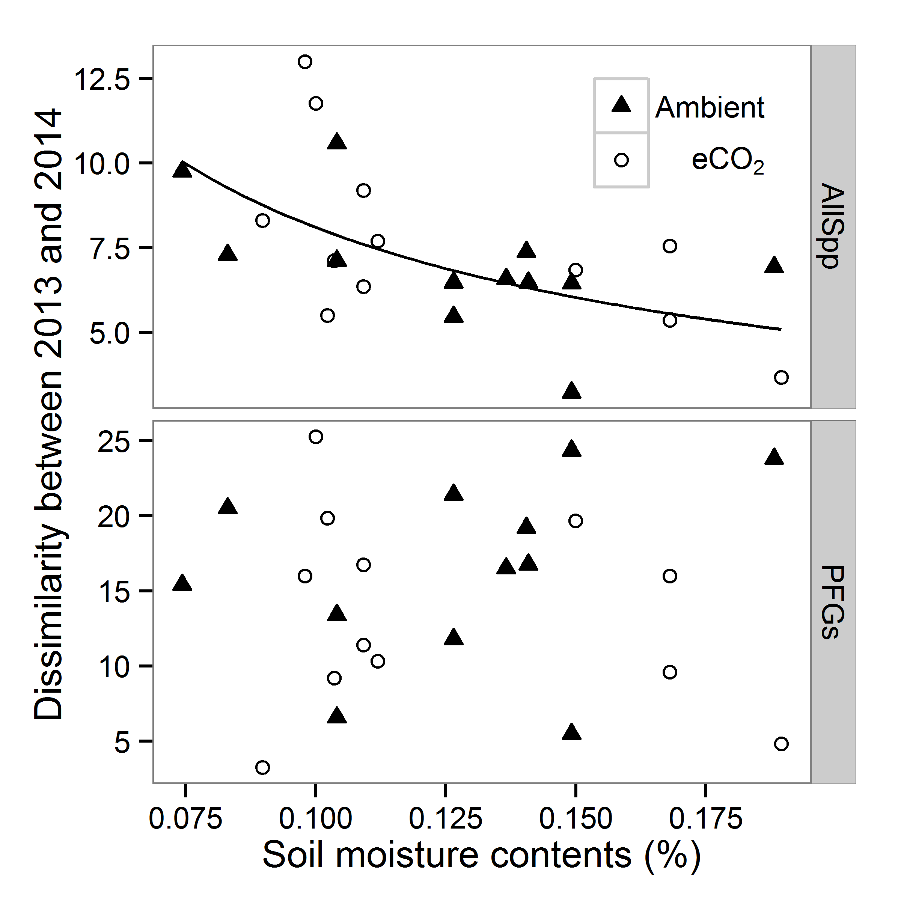

The above analyses were done by generalised linear mixed effect models (GLMM).

* **Multidimensional scaling (metric MDS)**
  + No distinctive separation between CO2 treatments (there is actually, but simply due to the pre-CO2 difference)
  + MDS1 may explain ring differences
  + MDS2 may explain year differences
  + MDS 3 may explain block (ring 1&2, ring 3&4, ring 5&6) differences

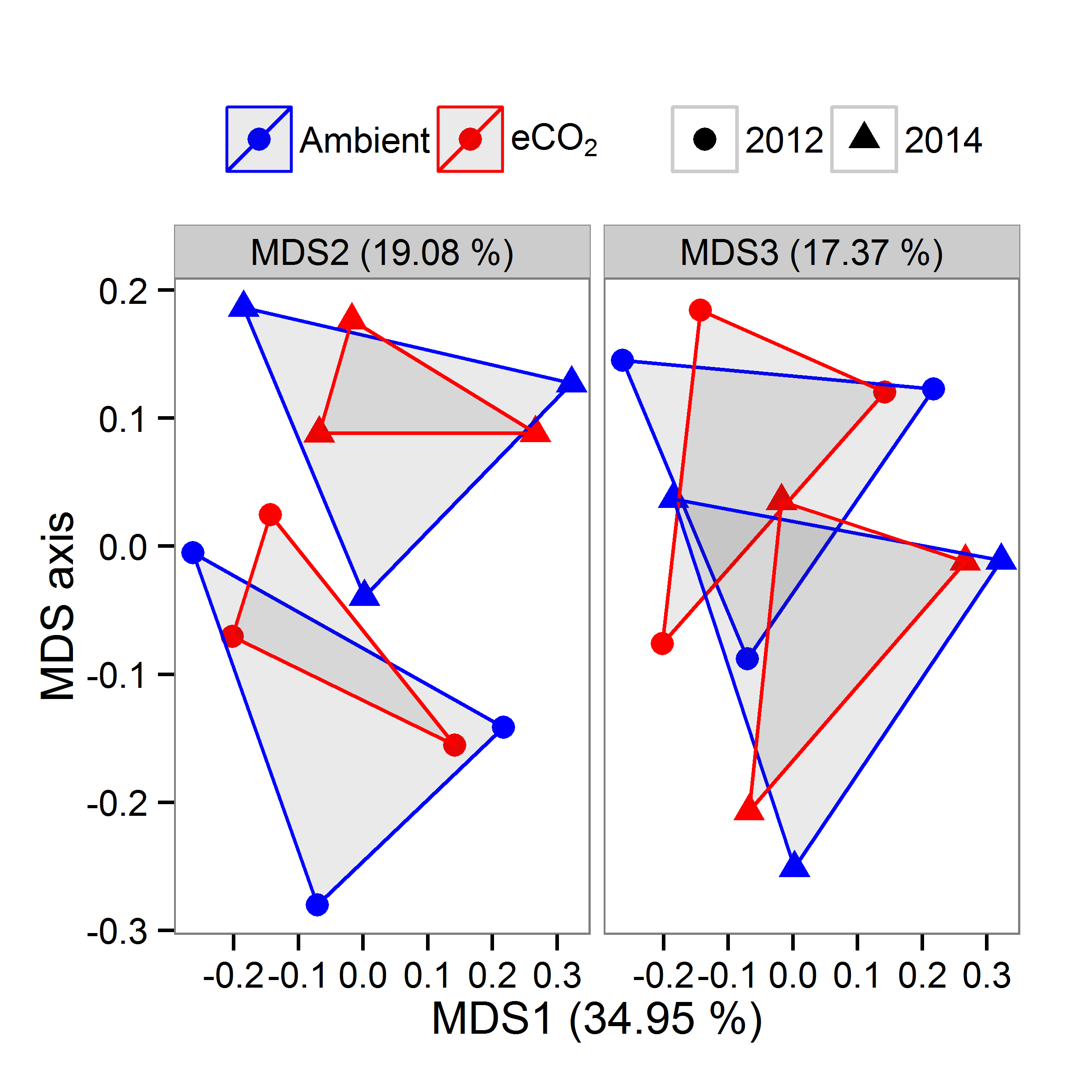

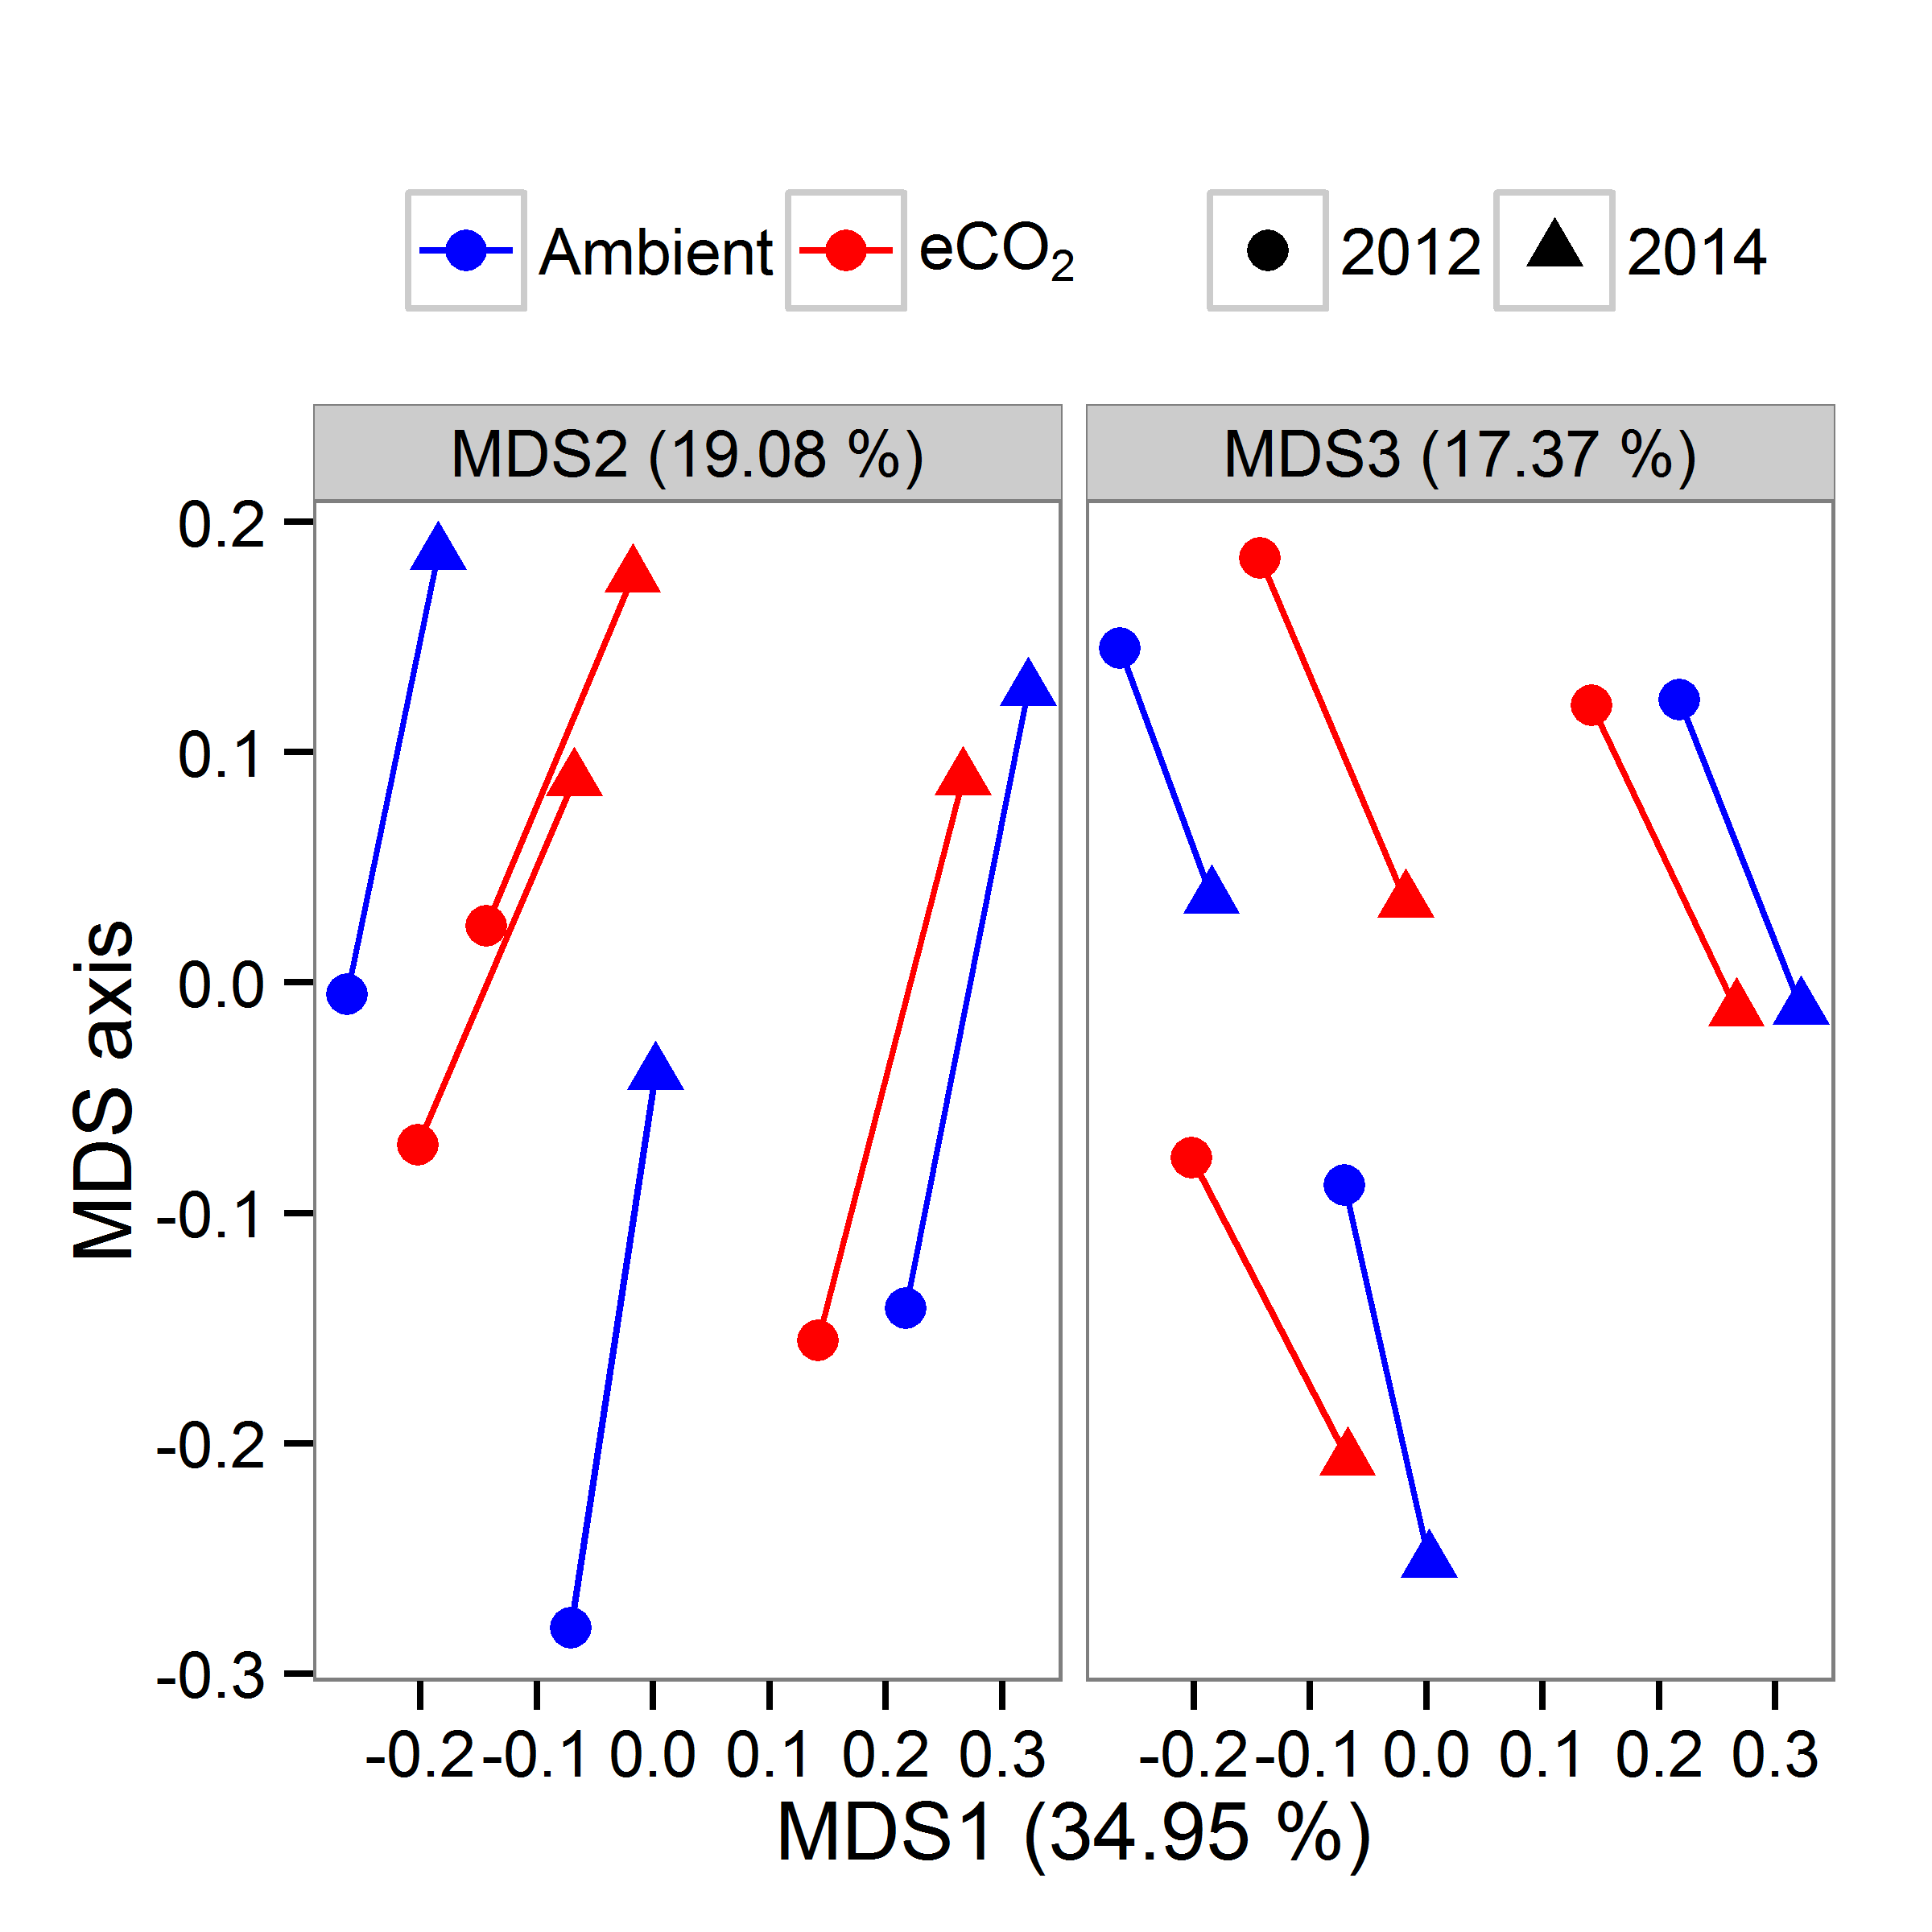

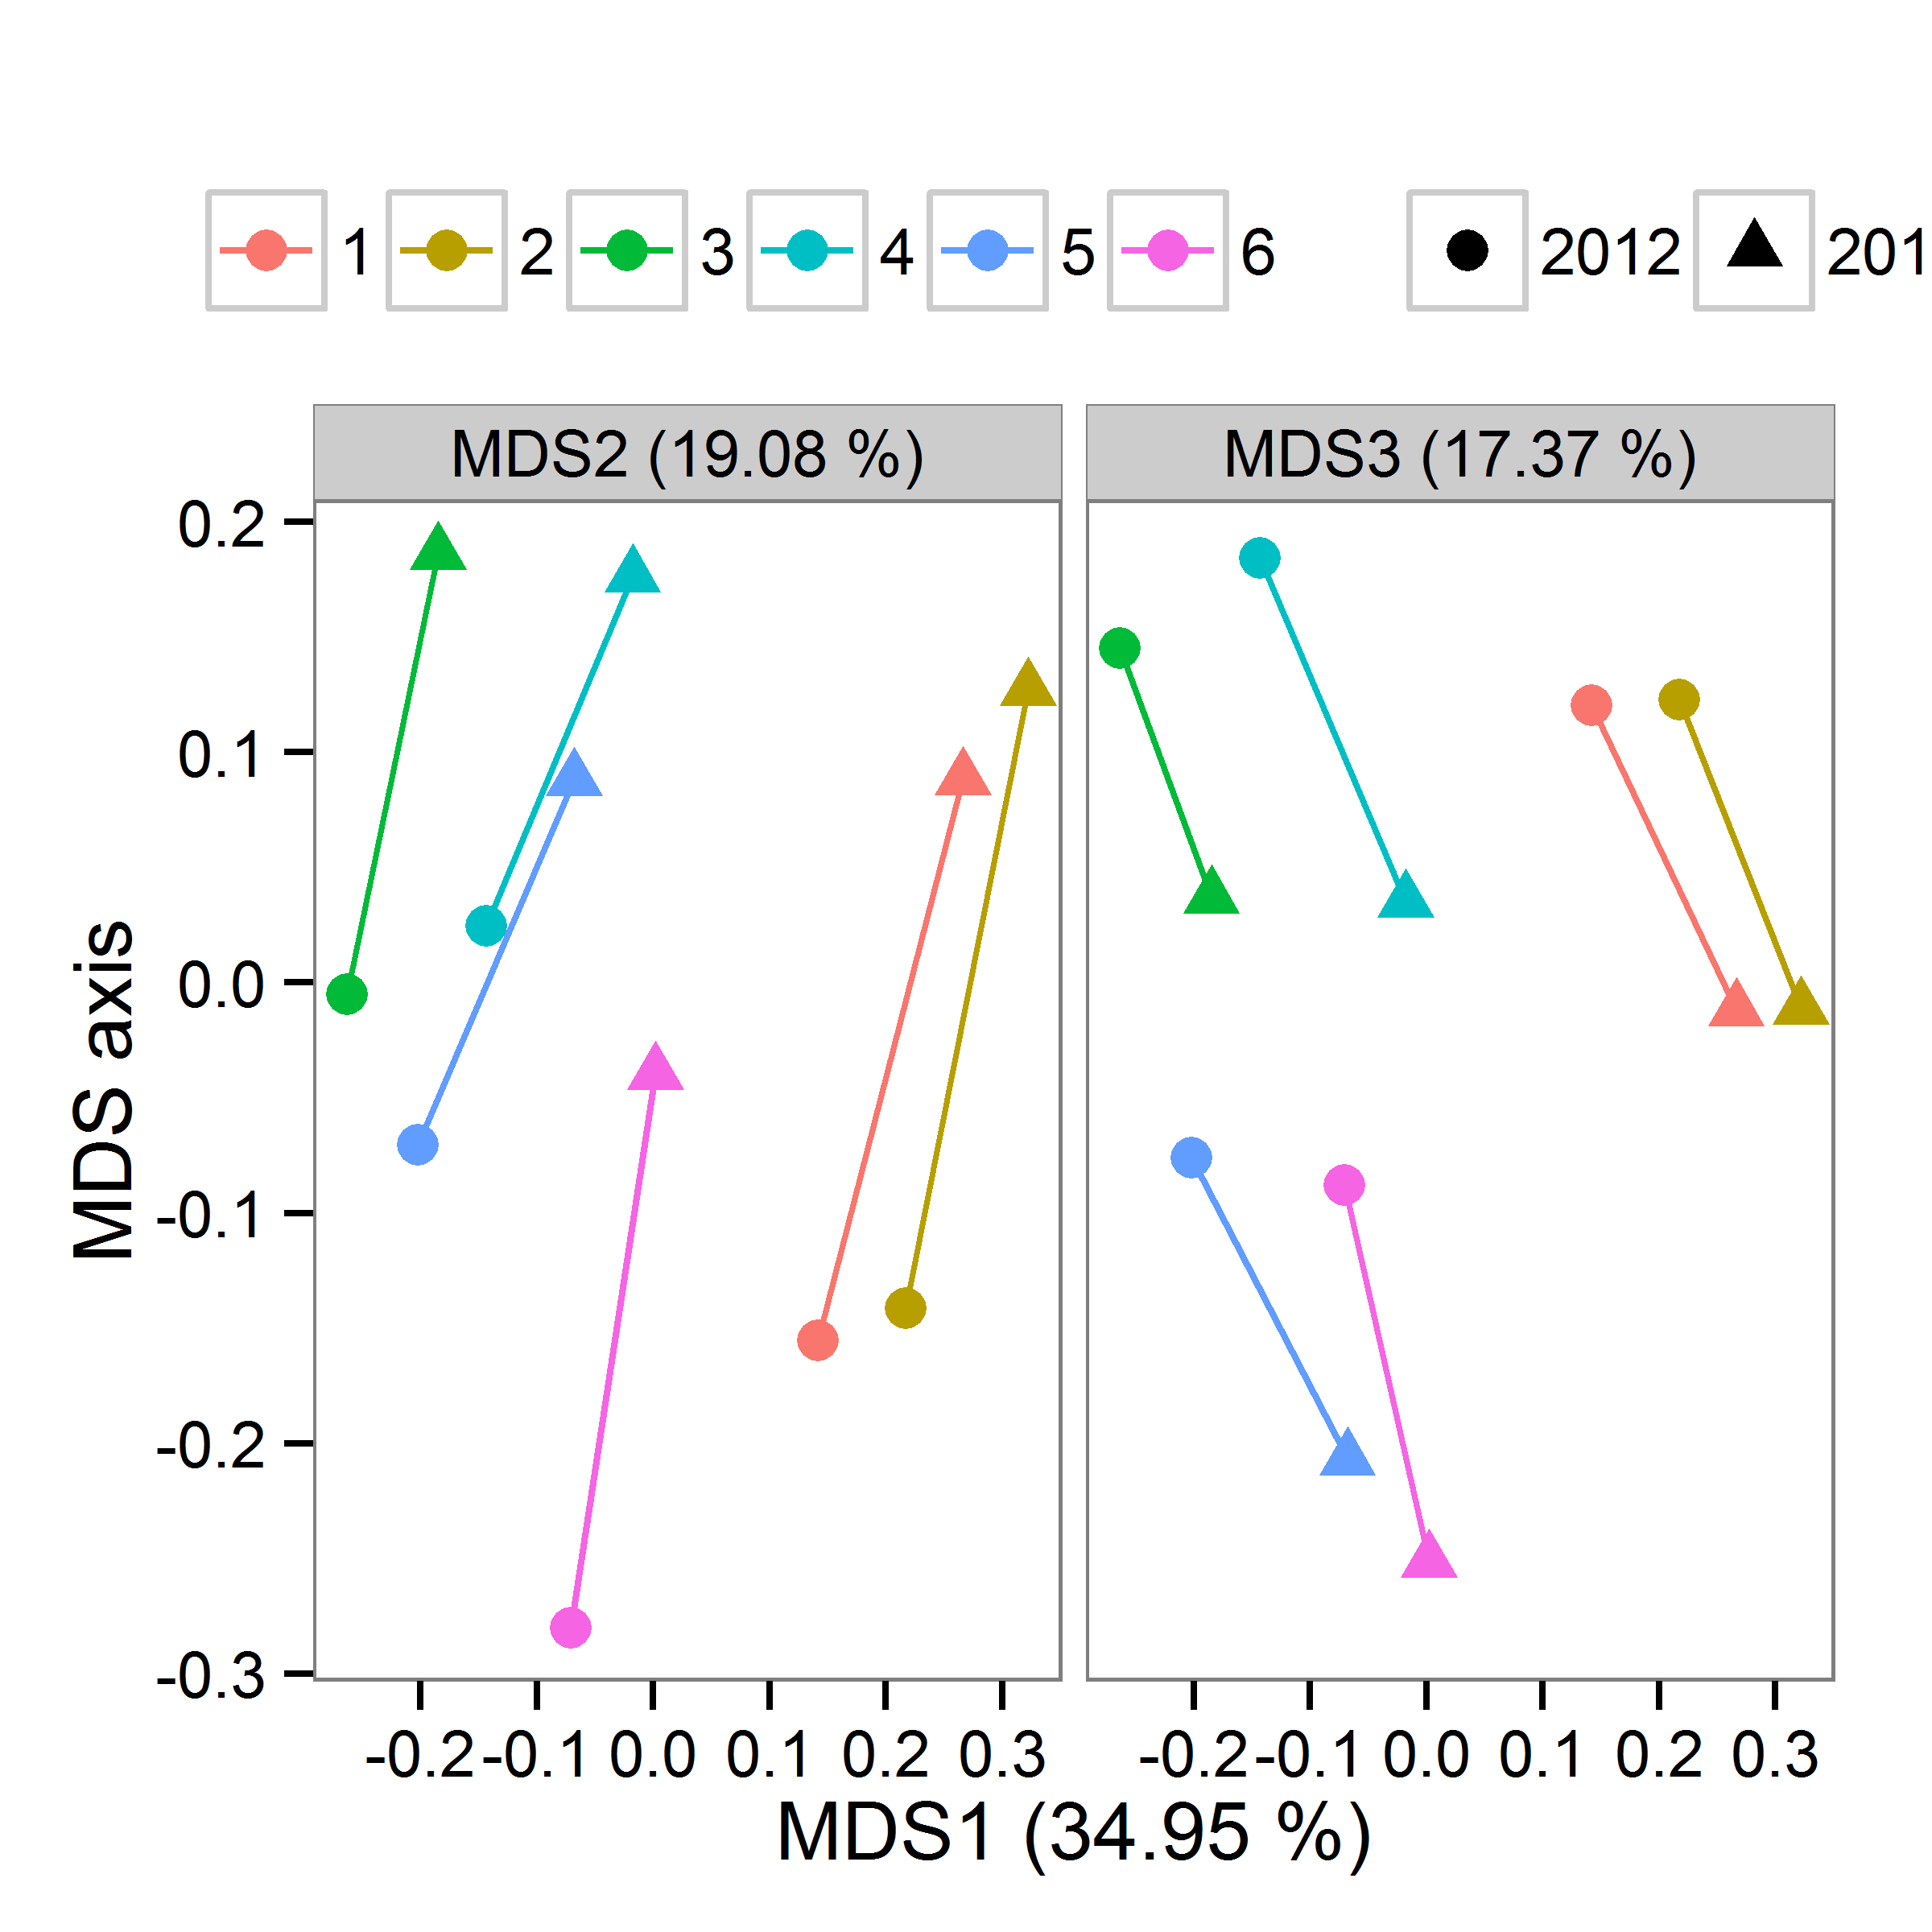

* **Correspondence analysis (CA)**
  + May be MDS above better explain the data

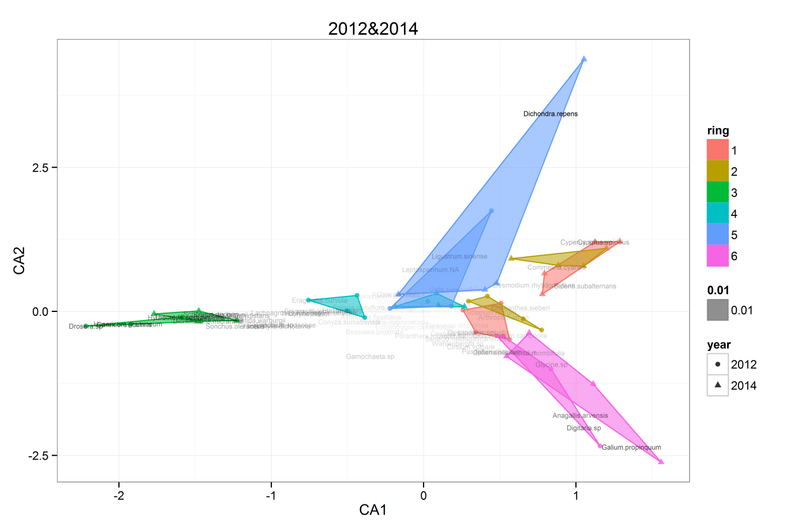

* **Next Plan**
  + **GLMM**:the analyses shown here are preliminary results. I need to do more reading to be confident with the outcome of GLMMs**.** I can run R codes but not confident with model diagnosis and robustness or reliability of the outcome produced by GLMMs.
  + **Multivariate analysis:** 
    - I’m planning to do canonical analysis of principal coordinate (CAP) developed by Anderson and Willis (2003). Ordinary distant based analysis such as PCA or MDS draws axes which maximise explained variance. On the other hand, CAP draw axes which maximise the separation between treatments of user’s interest (Please see the fig below from their paper). Most of variation from EucFACE vegetation data is simply due to spatial variation (between-ring variation), so CO2 effects wouldn’t effectively show up on PCA or MDS axes. CAP may be able to show separation between CO2 treatments (it’ll be really small anyway though); then we might be able to see driving spp or PFGs.
    - Fitting environmental variables: I haven’t still decided how to handle this… environmental variables are not much available for the 1st year data. Also those variables are not really corresponding to vegetation plots. TDR measures have 8 replicates for each ring so I can just choose the closest one though as I did for IEM data
  + Start structuring data chapter for this data
    - Having said that I need to do more reading and further analysis, I don’t think spending too much time on analysis is that good idea (as I very often fall into…..), so I need to move onto reading for writing this chapter.



**References**

* + Anderson MJ, Willis TJ (2003) Canonical analysis of principal coordinates: A useful method of constrained ordination for ecology. *Ecology,* **84**, 511-525.